WAN Device Modules (Instructor Version)
Instructor Note: Red font color or Gray highlights indicate text that appears in the instructor copy only.
Objective
Select WAN access technologies to satisfy business requirements in a small-to-medium-sized business network.
Instructor Note: This activity can be completed individually or in small groups – it can then be shared and discussed with another group of students, with the entire class, or with the instructor.
Scenario
Your medium-sized company is upgrading its network. To make the most of the equipment currently in use, you decide to purchase WAN modules instead of new equipment.
All branch offices use either Cisco 1900 or 2911 series ISRs. You will be updating these routers in several locations. Each branch has its own ISP requirements to consider.
To update the devices, focus on the following WAN modules access types:
- Ethernet
- Broadband
- T1/E1 and ISDN PRI
- BRI
- Serial
- T1 and E1 Trunk Voice and WAN
- Wireless LANs and WANs
Resources
- World Wide Web
- Word processing software
Directions
  - Visit Interfaces and Modules. On this page, you will see many options ISR interface modules options – remember that you currently own and use only the Cisco 1900 and 2900 series routers.
Note: If the above link is no longer valid, search the Cisco site for “Interfaces and Modules”.
  - Create a comparison matrix listing the following WAN access types for your branch networks:
- Ethernet
- Broadband
- T1/E1 and ISDN PRI
- BRI
- Serial WAN
- T1 and E1Trunk Voice and WAN
- Wireless LANs and WANs
  - In the matrix, record the interface module type you need to purchase for your ISRs for upgrade purposes.
  - Use the Internet to research pictures of the modules. Provide a screenshot of the module or a hyperlink to a picture of each module.
  - Share your matrix with a classmate, group, class, or your instructor.
Suggested Activity Example Solution:
Instructor Notes:
- This is a good place to have students discuss the terminology. For instance, WIC2T = WAN Interface Card with 2 serial ports.
- Students can also add various cards to routers in PT and use commands such as show ip interface brief to view the changes.
- Please encourage students to read the datasheet information listed on the modular card graphics sites – they will become familiar with different interface types by doing so.
- All graphics will vary as shown in the students’ final matrix – the graphics shown in this Activity Example Solution are representative in nature and were copied from the Cisco products sites. Each graphic is hyperlinked to the source available at the time this activity was created.
WAN Access Type | 2900 and 1900 Series Module Availability | Module (interface card) Example  (* from Column 2 indicates the graphic shown)
Ethernet | - EHWIC 1-port dual mode SFP(100M/1G) or GE(10M/100M/1G)*  - 2-port 10/100 Routed-Port HWIC | 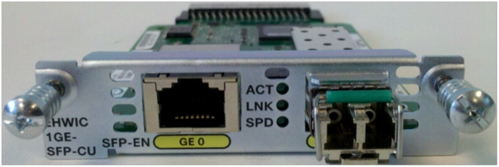
Broadband | - Multimode VDSL2/ADSL/2/2+ EHWIC Annex (A, B, and M variations)*  - Multimode EFM/ATM SHDSL EHWIC  - 4-pair G.SHDSL HWIC with 2-wire, 4-wire, and 8-wire support or 2-pair G.SHDSL HWIC with 2-wire and 4-wire support | 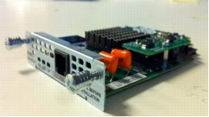
T1/E1 and ISDN PRI | (for use with 2900 series only)  - 2-port Channelized E1/T1/ISDN PRI HWIC*  - 1-port Channelized E1/T1/ISDN PRI HWIC | 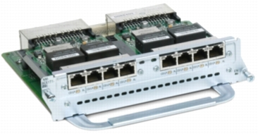
BRI | (for use with 2900 series only)  - 2-port VIC card-BRI (NT and TE  (for use with 2900 and 1900 series)  - 4-port ISDN BRI High-Speed WAN Interface Card*  - 1-port ISDN BRI U High-Speed WAN Interface Card  - 1-port ISDN WAN Interface Card (dial and leased line) | 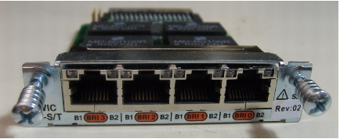
Serial | (for use with 2900 series only)  - One-port clear-channel T3/E3 Service Module  - 4-port clear-channel T1/E1 HWIC  - 4-port serial HWI  (for use with 2900 and 1900 series)  - 1-Port 4-Wire 56/64 Kpbs CSU/DSU WAN Interface Card  - 1-Port T1/Fractional T1 DSU/CSU High-Speed WAN Interface Card*  - 1-Port Serial High-Speed WAN Interface Card  - 2-Port Serial High-Speed WAN Interface Card | 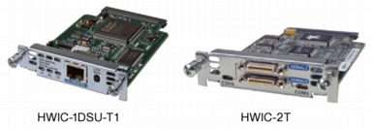
T1/E1 Trunk Voice and WAN | - 1-port T1/E1 Voice / WAN w/ D&I & unstructured E1 (G703)¹  - 2-port T1/E1 Voice / WAN w/ Drop & Insert  - 1-port T1/E1 Voice / WAN w/ Drop & Insert²  - 2-port T1/E1 Voice / WAN w/ D&I & unstructured E1 (G703)  - 1-port T1/E1 Voice / WAN w/ D&I & unstructured E1 (G703) | ¹  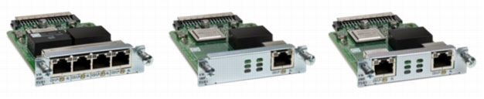  ²  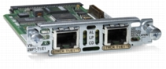
Wireless LANs and WAN | - Dedicated 4G LTE EHWIC for Verizon Wireless Network, US (Verizon SKU) operates on LTE at 700MHz (band 13) with GPS  - 4G LTE EHWIC for AT&T, 700 MHz Band 17, 850/1900/2100 MHz UMTS/HSPA  - 4G LTE EHWIC for Europe, LTE 800/900/1800/ 2100/2600 MHz, 900/1900/2100 MHz UMTS/HSPA bands  - (non-US) 3.7G HSPA+ Release 7 EHWIC w/ SMS/GPS (MC8705)  - ATT HSPA+ R7 EHWIC with SMS/GPS based on MC8705  - 3.5G EHWIC (Non-US) HSPA/UMTS 850/900/1900/2100MHz with SMS/GPS  - 3G EHWIC Verizon EV-DO Rev A/0/1xRTT 800/1900MHz with SMS/GPS  - 3G EHWIC Sprint EV-DO Rev A/0/1xRTT 800/1900MHz with SMS/GPS  - 3G EHWIC BSNL EV-DO Rev A/0/1xRTT 800/1900MHz with SMS/GPS  - 3G (for India only) HWIC TATA EVDO Rev A/0/1xRTT 800/1900MH | 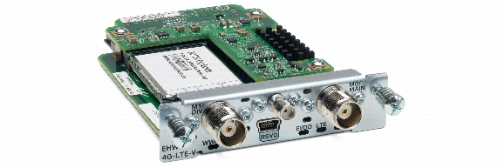

Identify elements of the model that map to IT-related content:
- WAN modular interfaces
- Network card interface types
- ISR module availability by model type

